**LAB CYCLE-1**

1. Define a class ‘product’ with data members pcode, pname and price. Create 3 objects of the class and find the product having the lowest price?

public class product

{

int pcode;

String pname;

double price;

double lowest;

void data(int c, String n, double p){

pcode=c;

pname=n;

price=p;

}

void display(){

System.out.println(pcode+"\t\t"+pname+"\t\t"+price);

}

static void findLowest(double price1,double price2, double price3){

if(price1<=price2 && price1<=price3){

System.out.println("\nProduct 1 is of the lowest price!");

}

else if(price2<=price1 && price2<=price3){

System.out.println("\nProduct 2 is of the lowest price!");

}

else{

System.out.println("\nProduct 3 is of the lowest price!");

}

}

public static void main(String[] args){

product obj1 = new product();

product obj2 = new product();

product obj3 = new product();

System.out.println("Lakshmi Hari");

System.out.println("SJC22MCA-037");

System.out.println("28-3-2023");

System.out.println("Object oriented programming lab");

System.out.println("20MCA132");

obj1.data(101,"Product_1",100.0);

obj2.data(102,"Product_2",128.40);

obj3.data(103,"Product_3",790.00);

System.out.println("Product Information:\n Product_Code\tProduct_Name\tProduct_Price");

obj1.display();

obj2.display();

obj3.display();

findLowest(obj1.price,obj2.price,obj3.price);

}

}

Output

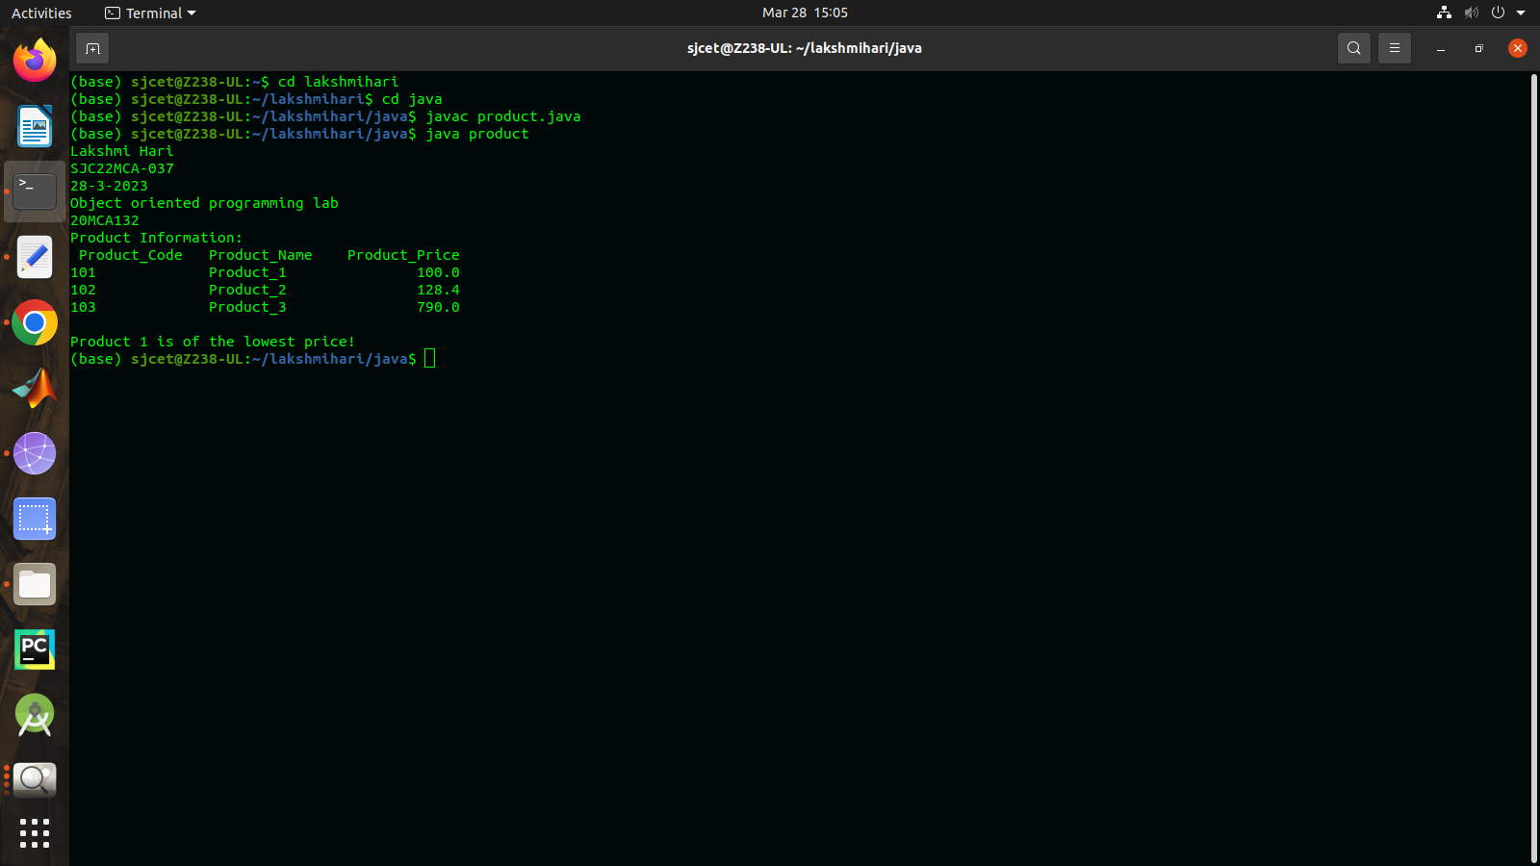

2.Read 2 matrices from the console and perform matrix addition?

import java.util.Scanner;

public class add_matrix {

public static void main(String args[])

{

int row, col,i,j;

System.out.println("Lakshmi Hari");

System.out.println("SJC22MCA-037");

System.out.println("28-3-2023");

System.out.println("Object oriented programming lab");

System.out.println("20MCA132");

Scanner in = new Scanner(System.in);

System.out.println("Enter the number of rows");

row = in.nextInt();

System.out.println("Enter the number columns");

col = in.nextInt();

int mat1[][] = new int[row][col];

int mat2[][] = new int[row][col];

int res[][] = new int[row][col];

System.out.println("Enter the elements of matrix 1");

for ( i= 0 ; i < row ; i++ )

{

for ( j= 0 ; j < col ;j++ )

mat1[i][j] = in.nextInt();

System.out.println();

}

System.out.println("Enter the elements of matrix 2");

for ( i= 0 ; i < row ; i++ )

{

for ( j= 0 ; j < col ;j++ )

mat2[i][j] = in.nextInt();

System.out.println();

}

for ( i= 0 ; i < row ; i++ )

for ( j= 0 ; j < col ;j++ )

res[i][j] = mat1[i][j] + mat2[i][j] ;

System.out.println("Sum of matrices:-");

for ( i= 0 ; i < row ; i++ )

{

for ( j= 0 ; j < col ;j++ )

System.out.print(res[i][j]+"\t");

System.out.println();

}

}

}

Output

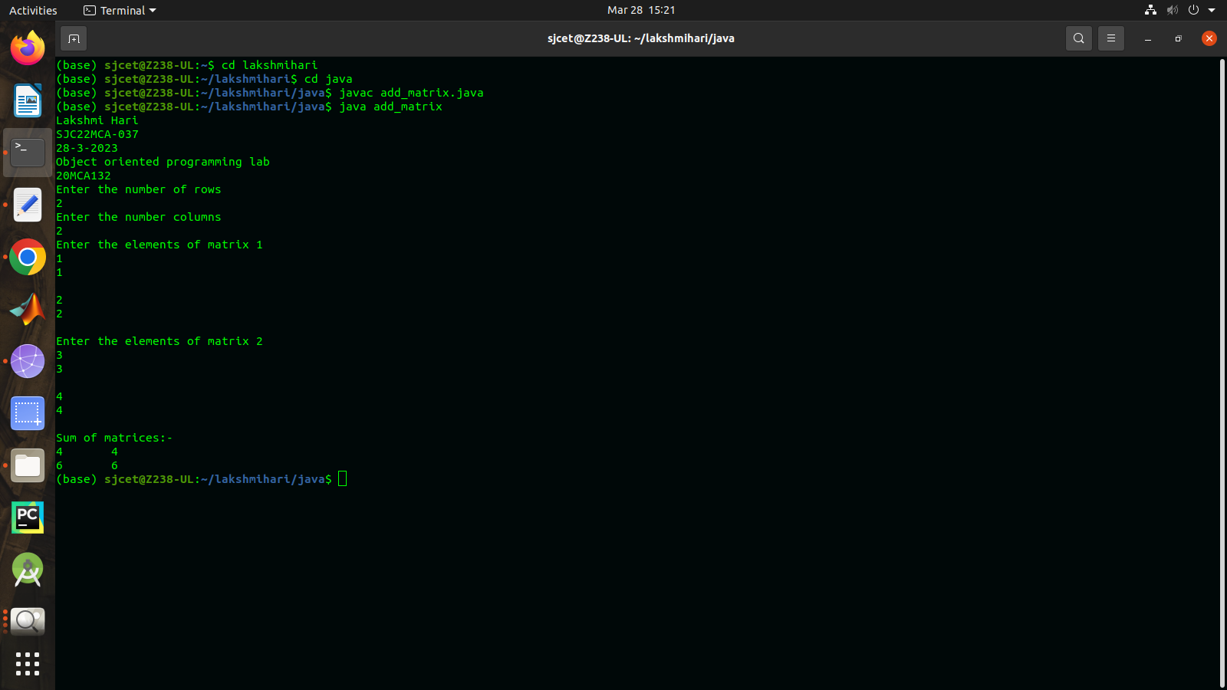

3.Add complex numbers?

public class complex {

int r;

int i;

complex(int real,int img){

r=real;

i=img;

}

void display(){

System.out.println(r+"+"+i+"i");

}

static void add(int r1,int i1,int r2,int i2 ){

r1=r1+r2;

i1=i1+i2;

System.out.println("After Addition = "+r1+"+"+i1+"i");

}

public static void main(String[] args) {

System.out.println("Lakshmi Hari");

System.out.println("SJC22MCA-037");

System.out.println("28-3-2023");

System.out.println("Object oriented programming lab");

System.out.println("20MCA132");

complex first=new complex(5,4);

complex second=new complex(7,9);

System.out.println("Complex Numbers are:");

first.display();

second.display();

add(first.r,first.i,second.r,second.i);

}

}

OutPut

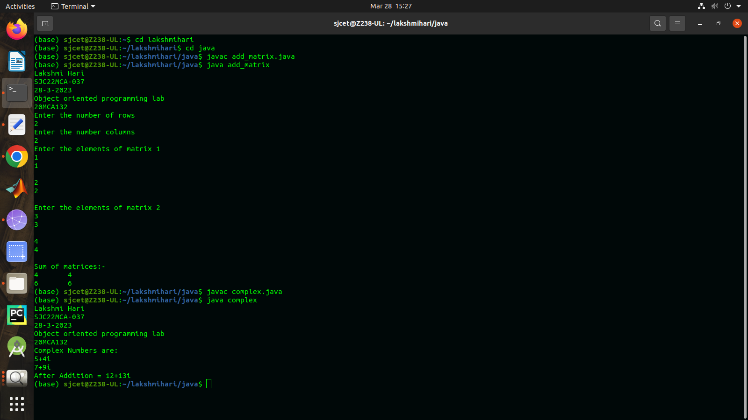

4.Read a matrix from the console and check whether it is symmetric or not?

import java.util.Scanner;

public class symmetric {

public static void main(String[] args) {

System.out.println("Lakshmi Hari");

System.out.println("SJC22MCA-037");

System.out.println("28-3-2023");

System.out.println("Object oriented programming lab");

System.out.println("20MCA132");

Scanner sc = new Scanner(System.in);

System.out.println("Enter the Number of rows of the Matrix");

int row = sc.nextInt();

System.out.println("Enter the Number of Columns of the Matrix");

int col = sc.nextInt();

int matrix[][] = new int[row][col];

int i,j;

boolean state=true;

for(i=0;i<row;i++){

for(j=0;j<col;j++){

System.out.println("Enter the Element at M("+i+","+j+")");

matrix[i][j] = sc.nextInt();

}

}

for(i=0;i<row;i++){

for(j=0;j<col;j++){

if(matrix[i][j]!=matrix[j][i]){

state=false;

break;

}

}

}

if(state){

System.out.println("Matrix is Symmetric");

}

else{

System.out.println("Matrix is Antisymmetric");

}

}

}

Output

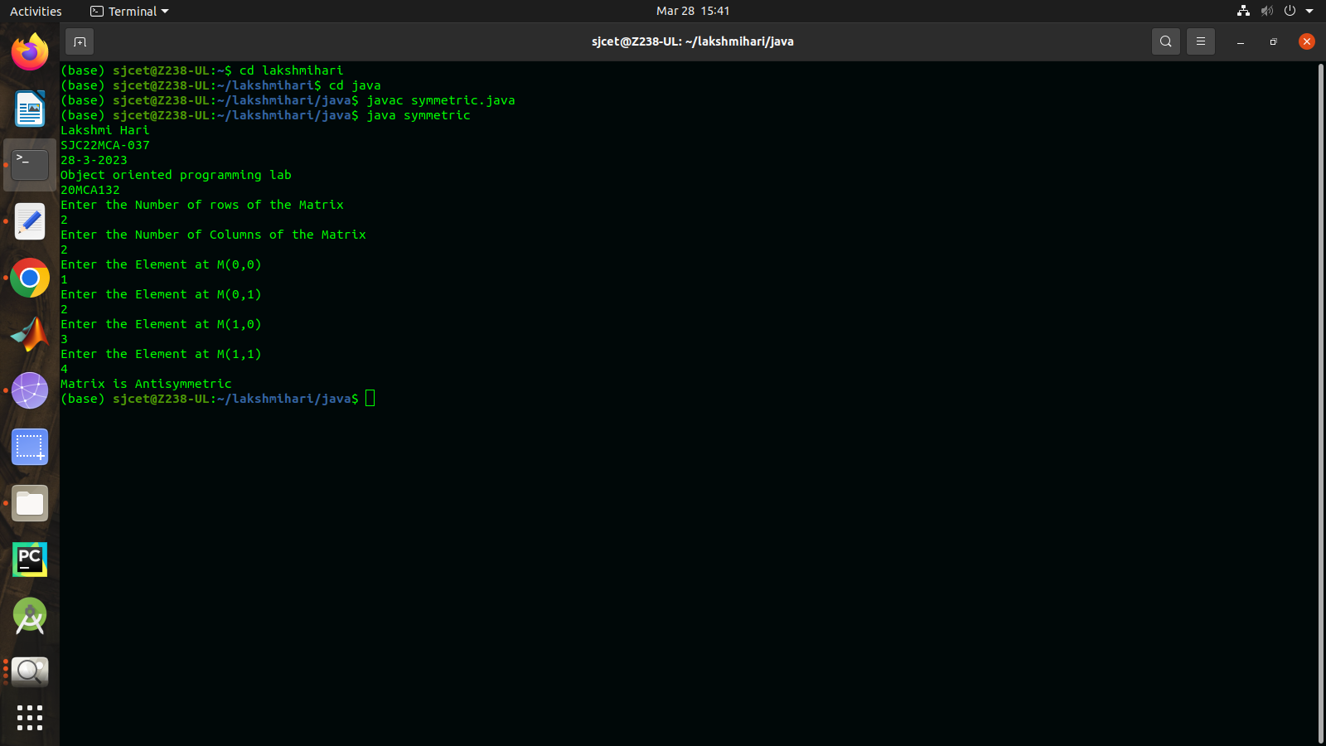

5.Create CPU with attribute price. Create inner class Processor (no. of cores, manufacturer) and static nested class RAM (memory,manufacturer). Create an object of CPU and print information of Processor and RAM?

public class cpu{

int price;

class processor{

int cores;

String producer;

processor(int noC, String manu){

cores=noC;

producer=manu;

}

void display(){

System.out.println("\nProcessor info");

System.out.println("No. of Cores = "+cores);

System.out.println("Manufacturer = "+producer+"\n");

}

}

static class ram{

int mem;

String manuf;

ram(int memory,String producer ){

mem=memory;

manuf=producer;

}

void display(){

System.out.println("\nRAM info");

System.out.println("Memory = "+mem+" GB");

System.out.println("Manufacturer = "+manuf+"\n");

}}

public static void main(String[] args) {

System.out.println("Lakshmi Hari");

System.out.println("SJC22MCA-037");

System.out.println("28-3-2023");

System.out.println("Object oriented programming lab");

System.out.println("20MCA132");

cpu.ram obj1= new cpu.ram(8,"Intel");

cpu obj2 = new cpu();

cpu.processor obj3 = obj2.new processor(8,"Samsung");

obj1.display();

obj3.display();

}

}

Output

